Week-5 Individual Deliverable Report
By Shaurya Parshad

Executive Summary
I developed three machine learning models to predict chronic kidney disease using 200 patient medical records. After addressing several data quality issues, the final models achieved 97.5% to 100% accuracy. This report documents the process, challenges encountered, and results.

Project Overview

The Dataset
- Total patients: 200 (128 with CKD, 72 healthy)
- Medical measurements: 26 different health indicators
- Data split: 64% CKD patients, 36% healthy (reasonably balanced)

The Process & Challenges

Challenge 1: Messy Data Format
The dataset came with values in ranges and special characters that computers couldn't understand:
- Ages like "20-30" or ">=74"
- Urine measurements like "1.019-1.021"
- Excel accidentally converted "3-4" to "3-Mar" (a date!)
Solution: I wrote a conversion function that:
- Turns ranges into averages (e.g., "20-30" becomes 25)
- Handles comparison symbols (e.g., ">=74" becomes 74)
- Fixes Excel's date conversions (e.g., "3-Mar" back to 3.5)

Challenge 2: Missing Class Labels
One patient record had no diagnosis label - we didn't know if they had CKD or not. This single missing value caused the entire system to crash.
Solution: Removed that one incomplete record before training. Final dataset: 200 clean records.

Challenge 3: Data Leakage (The Big Problem)
My first models showed 100% perfect accuracy, which sounds great but was actually wrong! I discovered two features that were "cheating":
- "Affected" feature - This literally means "has CKD." Using it to predict CKD is like asking "Does this sick person have the disease?" to predict if they're sick. Circular logic!
- "Stage" feature - CKD stage (1-5) is determined AFTER a doctor diagnoses you. You can't use it to make the diagnosis in the first place.
Solution: Removed both features. Accuracy dropped from 100% to 97.5%, which is more realistic.

Challenge 4: Train-Test Split
I split my data into two groups:
- Training set (160 patients, 80%): The models learn patterns from this data
- Test set (40 patients, 20%): Used to check if the models actually learned or just memorized
This prevents the model from "studying with the answer key" for the final exam.

Understanding the Results

Model Performance
Model | Training Accuracy | Testing Accuracy
Logistic Regression | 100% | 97.5%
Decision Tree | 100% | 97.5%
Random Forest | 100% | 100%
What This Means:
- Logistic Regression (97.5%): Correctly identified 39 out of 40 patients. Missed 1 patient.
- Decision Tree (97.5%): Also got 39 out of 40 correct. This consistency with Logistic Regression is a good sign.
- Random Forest (100%): Got all 40 test patients correct, but this might be "overfitting" - the model may have memorized patterns instead of learning general rules. With only 40 test cases, it's hard to tell. I'll test this more thoroughly in Week 6 using cross-validation.

Understanding the Visualizations

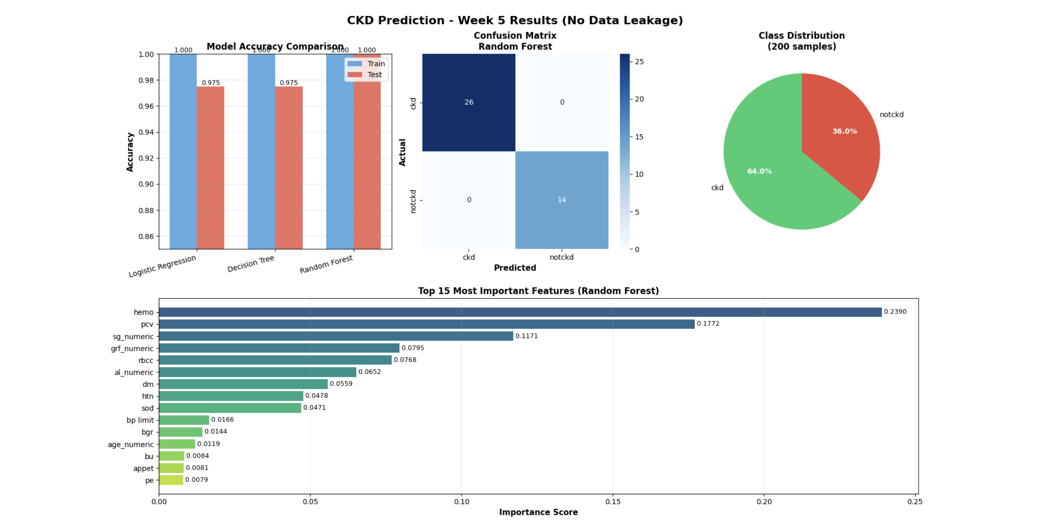

Chart 1: Model Accuracy Comparison (Top Left)
Shows blue bars (training) and red bars (testing) for each model. All models learned the training data perfectly (100%), but only Random Forest maintained perfect accuracy on new patients.

Chart 2: Confusion Matrix (Top Middle)
This grid shows Random Forest's predictions:
- Top-left (26): Correctly identified 26 CKD patients as having CKD
- Bottom-right (14): Correctly identified 14 healthy people as healthy
- Top-right (0): Never mistakenly said a healthy person had CKD
- Bottom-left (0): Never missed a CKD patient
Perfect score, but again, this needs more testing.

Chart 3: Class Distribution (Top Right)
The pie chart shows our dataset has almost twice as many CKD patients (64%) as healthy patients (36%). This is better than my original dataset which was 94% CKD - too imbalanced to train properly.

Chart 4: Feature Importance (Bottom)
This bar chart ranks which medical tests matter most for prediction. Longer bars = more important for detecting CKD.

The Medical Indicators: What They Mean
Here are the top 10 most important health measurements for detecting CKD, explained in plain English:

1. Hemoglobin (23.9% importance)
What it is: The protein in red blood cells that carries oxygen throughout your body.
Normal range: 13.5-17.5 g/dL (men), 12-15.5 g/dL (women)
Why it matters for kidneys: Healthy kidneys make a hormone called erythropoietin that tells your body to produce red blood cells. When kidneys fail, they make less of this hormone, so you end up with less hemoglobin. Low hemoglobin = possible kidney damage.
Effect: Patients with CKD often have anemia (low hemoglobin), causing fatigue and weakness.

2. Packed Cell Volume / PCV (17.7% importance)
What it is: The percentage of your blood that's made up of red blood cells.
Normal range: 40-50% (men), 36-44% (women)
Why it matters for kidneys: Directly related to hemoglobin. When kidneys don't signal for enough red blood cell production, PCV drops. It's like measuring how "thick" your blood is with cells.
Effect: Low PCV means thin, watery blood that can't carry enough oxygen, making you tired and dizzy.

3. Specific Gravity / SG (11.7% importance)
What it is: Measures how concentrated your urine is compared to pure water.
Normal range: 1.005-1.030
Why it matters for kidneys: Healthy kidneys concentrate urine by filtering out water and keeping important stuff. Damaged kidneys can't concentrate properly, so urine specific gravity stays around 1.010 (very dilute) no matter what.
Effect: If your urine specific gravity doesn't change throughout the day, your kidneys aren't adjusting fluid balance properly.

4. GRF - Glomerular Filtration Rate (8.0% importance)
What it is: Measures how much blood your kidneys filter per minute.
Normal range: 90-120 mL/min
Why it matters for kidneys: This is THE direct measure of kidney function. It's like measuring the speed of a water filter. Low GRF = kidneys are filtering slowly = kidney damage.
Effect: GRF below 60 for 3+ months = chronic kidney disease diagnosis. Below 15 = kidney failure, need dialysis.

5. Red Blood Cell Count / RBCC (7.7% importance)
What it is: The actual number of red blood cells in your blood.
Normal range: 4.5-5.5 million cells/µL (men), 4.0-5.0 million cells/µL (women)
Why it matters for kidneys: Same reason as hemoglobin and PCV - damaged kidneys don't signal for enough red blood cell production.
Effect: Low red blood cell count = not enough oxygen delivery = chronic tiredness.

6. Albumin / AL (6.5% importance)
What it is: A protein that should stay in your blood, not leak into urine.
Normal range: 0 in urine (none should be there)
Why it matters for kidneys: Healthy kidneys filter waste but keep important proteins like albumin in your blood. Damaged kidney filters become "leaky" and let albumin spill into urine.
Effect: Albumin in urine (albuminuria) is an early warning sign of kidney damage, often appearing years before other symptoms.

7. Diabetes Mellitus / DM (5.6% importance)
What it is: Whether the patient has diabetes (high blood sugar disease).
Why it matters for kidneys: High blood sugar damages tiny blood vessels in the kidneys over time. Diabetes is the #1 cause of kidney disease in developed countries.
Effect: About 1 in 3 people with diabetes develop kidney disease. Controlling blood sugar prevents this.

8. Hypertension / HTN (4.8% importance)
What it is: High blood pressure.
Normal range: Below 120/80 mmHg
Why it matters for kidneys: High pressure damages the delicate filtering units in kidneys (nephrons). It's like forcing water through a coffee filter at high pressure - eventually it tears. Also, damaged kidneys CAUSE high blood pressure, creating a vicious cycle.
Effect: Hypertension is the #2 cause of kidney disease after diabetes.

9. Sodium / SOD (4.7% importance)
What it is: Salt levels in your blood.
Normal range: 135-145 mEq/L
Why it matters for kidneys: Kidneys regulate sodium to control blood pressure and fluid balance. When kidneys fail, they can't regulate sodium properly, leading to swelling (edema) and high blood pressure.
Effect: Abnormal sodium can indicate the kidneys aren't balancing fluids correctly.

10. Blood Pressure Limit (1.7% importance)
What it is: Classification of blood pressure as normal or high.
Why it matters for kidneys: As mentioned with hypertension, high BP both causes and results from kidney damage.
Effect: Monitoring BP helps track kidney disease progression.

Other Important Indicators (Not in Top 10 but Still Measured)
- Blood Urea (BU): Waste product kidneys should filter out. High levels = kidneys not cleaning blood properly.
- Serum Creatinine (SC): Another waste product. High levels = reduced kidney function.
- Potassium (POT): Kidneys regulate this. Too high or low = kidney problems.
- White Blood Cell Count (WBCC): Can indicate infection or inflammation affecting kidneys.
- Pus Cells, Bacteria: Signs of kidney infection.
- Red Blood Cells in Urine: Shouldn't be there; indicates kidney damage or stones.
- Coronary Artery Disease (CAD): Heart and kidney health are connected.
- Appetite: CKD patients often lose appetite due to toxin buildup.
- Pedal Edema (PE): Swollen feet/ankles from fluid retention when kidneys can't remove excess water.
- Anemia (ANE): Low red blood cell count, common in CKD.

